DASH Azure Blob Access Guide

Prerequisites
- Azure CLI: Install and configure the Azure CLI on your local machine to run the commands below.
  - Install Azure CLI

Input Guide
This outlines the input parameters available during Azure Blob provisioning via the DASH Portal. Each row describes a specific parameter, including its meaning, possible values, recommended values, and any valid combinations.

Input Parameter | Description | Values Provided | Value Guidance | Valid Combinations
Region | Azure region where resources will be deployed. | East US, Central US, West US 2, Central India, UK South, Canada Central, East Asia, South Central US | Choose region closest to workload for better latency. | N/A
Storage Account Tier | Defines the performance tier of the storage account. | Standard, Premium | Standard:  Default performance tier suitable for general-purpose storage.  Premium: High-performance tier for BlockBlobStorage or FileStorage. | Premium requires account kind BlockBlobStorage or FileStorage.
Storage Account Redundancy | Specifies how data is replicated across Azure regions. | LRS, GRS, RAGRS, ZRS, GZRS, RAGZRS | LRS:  Locally Redundant Storage (3 copies within one datacenter)  GRS: Geo-Redundant Storage (replication to a secondary region)  RAGRS: Read-Access GRS (GRS + read access to the secondary region)  ZRS: Zone-Redundant Storage (replication across availability zones)  GZRS:  Geo-Zone Redundant Storage (ZRS + cross-region)  RAGZRS: Read-Access GZRS (GZRS + read access to secondary) | Premium supports only LRS & ZRS; Standard supports all.
Storage Account Kind | Type of storage account to be created. | StorageV2, BlobStorage, BlockBlobStorage, FileStorage, Storage | StorageV2: Recommended. Supports all modern features including Data Lake Gen2  Blob Storage: Blob-only, used in legacy scenarios  BlockBlobStorage: Premium block blob storage (requires Premium tier)  FileStorage: Premium file storage (requires Premium tier).  Storage:  Legacy storage account. Limited and not recommended | BlockBlobStorage and FileStorage require Premium tier.
Enable Hierarchical Namespace | Enables Azure Data Lake Gen2 features. | true, false | true:  - Enables file system-like folder structure  - Allows file/folder move and rename operations  - Optimized for analytics tools like Databricks, HDInsight, Synapse  - Required for Azure Data Lake Gen2 features  false:  - Default option  - Standard blob storage behavior (no folder hierarchy) | is_hns_enabled = true is recommended when the storage account is intended for big data analytics or when using Data Lake Gen2 features.  Compatible with StorageV2 and account tier = Standard (most common use case).  LRS, ZRS, GRS, RAGRS, GZRS, RAGZRS supported
Number of Containers | Defines how many blob containers to create. | 1, 2, 3, 4, 5 | Choose between 1 to 5. | Must match number of container names.
Container Names | Names of containers to be created. | Values must be provided by the user as a list, based on the number of containers required Example: ["logs", "backup", "assets"] | Lowercase, numbers, dashes only. | List size must match number of containers.
Container Access Type | Controls public access to containers. | blob, container, private | blob: Blob-only access  container: Full public access  private: No access | N/A
owner | The team or individual responsible for provisioning, managing, and maintaining the resource. | Specify the team name or individual responsible for maintaining the Azure blob. | Provide correct team/individual name. | N/A
application | Service or application associated with the blob. | Enter the name of the application or service that uses this blob. | Provide a service name linked to the blob. | N/A
project | Project or initiative name linked to the resource. | Indicate the project or initiative name related to the resource. | Provide the project name related to the resource. | N/A
deployment | The target environment (e.g., development, testing, prod) where the resource will be provisioned. | Define the deployment environment name (e.g., dev, test, prod) | Choose the environment where the Azure blob has to be deployed. | N/A
Services expire after 30 days. Create this service now, or schedule for a later date? | Azure blob will be deleted 30 days after creation, or it can be scheduled to be created at a later date. | Create Now (or)  Schedule for Later | Choose based on resource requirements. | N/A

Valid Tips:
Storage Type | Tier | LRS | ZRS | GRS | RAGRS | GZRS | RAGZRS
StorageV2 | Standard | ✅ | ✅ | ✅ | ✅ | ✅ | ✅
BlobStorage | Standard | ✅ | ✅ | ✅ | ✅ | ❌ | ❌
BlockBlobStorage | Premium | ✅ | ✅* | ❌ | ❌ | ❌ | ❌
FileStorage | Premium | ✅ | ✅* | ❌ | ❌ | ❌ | ❌
Storage (v1) | Standard | ✅ | ✅ | ✅ | ✅ | ❌ | ❌

Sample Input Selection: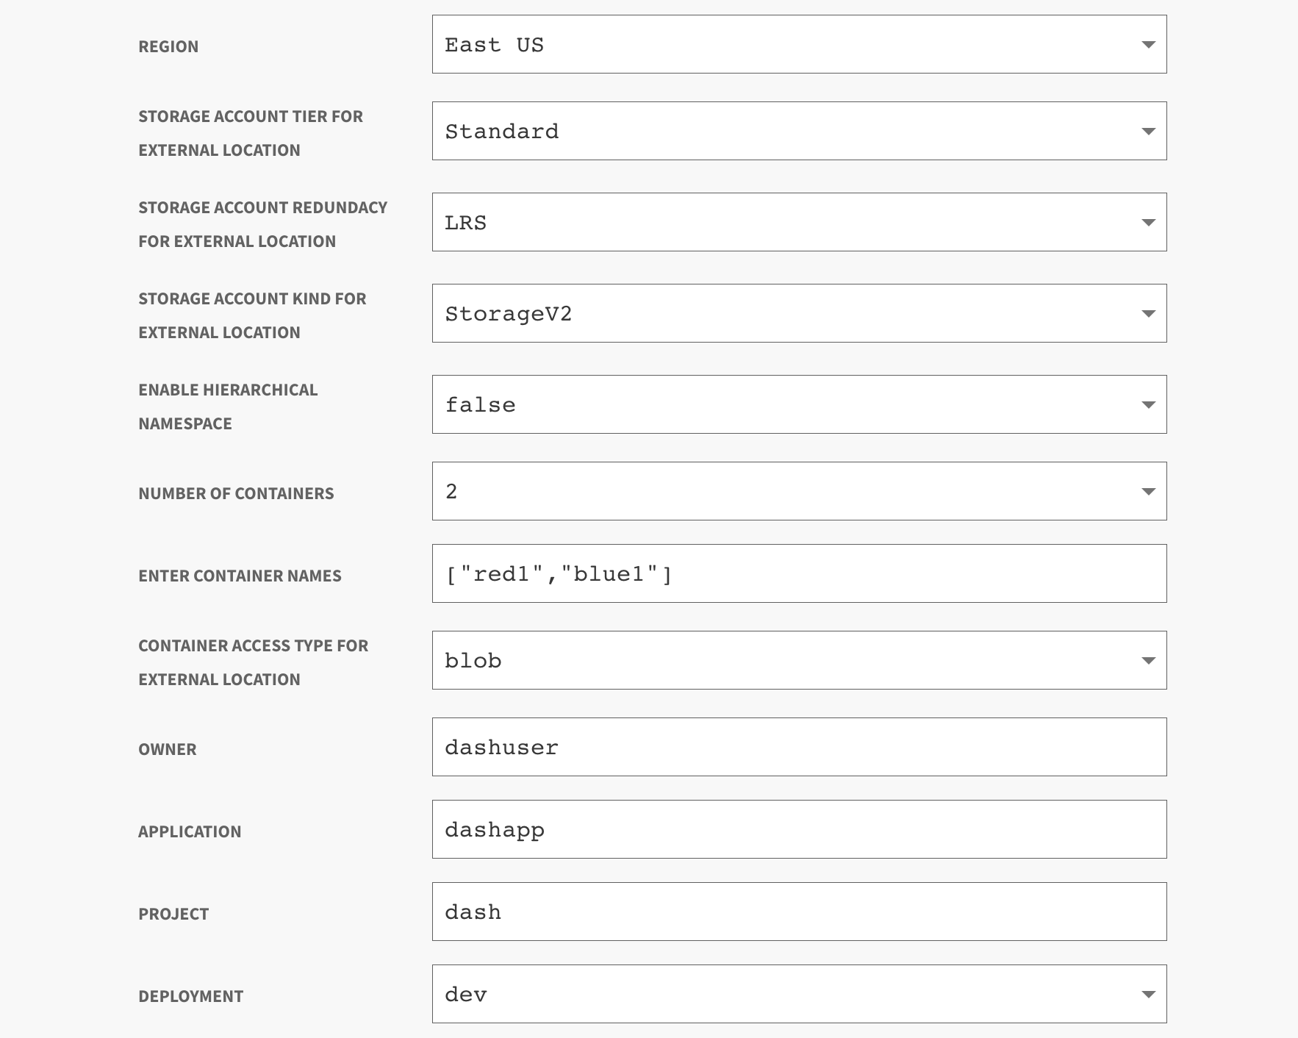
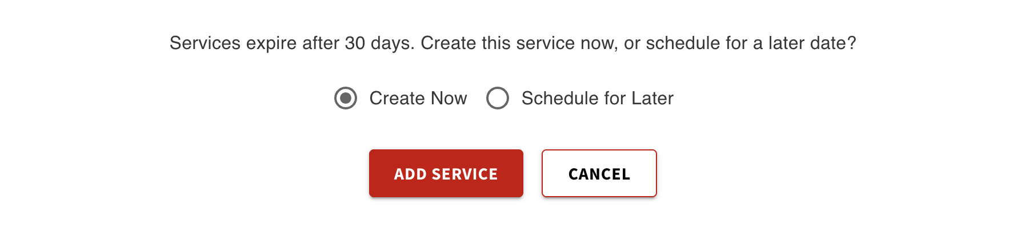

Output Guide

This document outlines the output values generated after Azure Blob Storage provisioning
through the DASH Portal. These values can be used to access, manage, and interact with
your storage containers.

Outputs | Description | Example Value
storage_account_name | The name of the Azure Storage Account that was provisioned. | dashstg1zsv
Storage_account_primary_access_key | Primary access key used to authenticate with the Storage Account. | z0Q6Yw9i7eF8fYABJqzRE+abcd12345abcdefg== (truncated)
storage_container_names | A list of Azure Blob container names created within the storage account. | ["logs", "backup", "assets"]
list_storage_containers_command | Azure CLI command to list all containers using name and access key.  az storage container list --account-name <storage_account_name> --account-key  <storage_account_primary_access_key> --output table | az storage container list --account-name dashstg1zsv --account-key  z0Q6Yw9i7eF8fYABJqzRE+abcd12345abcdefg== --output table

What You Can Do with These Outputs
Use the following Azure CLI commands to perform various operations on your blob containers. Replace placeholder values like <your-file>, <blob-name>, etc., with actual values.

Operation | Description | Command | Example Command
Upload a Blob | Uploads a file from local machine to a container in Azure Blob Storage. | az storage blob upload --account-name <name> --account-key <key> --container-name <container> --name <blob_name> --file <file_path> | az storage blob upload --account-name dashstg1zsv --account-key z0Q6Yw9i7eF8fYABJqzRE+abcd12345abcdefg== --container-name logs --name red1 --file ./myfolder/myfile.txt
List Blobs | Lists all blobs stored in a specific container. | az storage blob list --account-name <name> --account-key <key> --container-name <container> --output table | az storage blob list --account-name dashstg1zsv --account-key z0Q6Yw9i7eF8fYABJqzRE+abcd12345abcdefg== --container-name logs --output table
List Blobs with URLs | Lists blobs in a container along with accessible URLs. | az storage blob list --account-name <storage_account_name> --account-key < storage_account_primary_access_key > --container-name <container_name> --query '[]. {name:name, url:join(``, [`https://<storage_account_name>.blob.core.windows.net/<container_name>/`, name])}' --output table | az storage blob list --account-name dashstg1zsv --account-key z0Q6Yw9i7eF8fYABJqzRE+abcd12345abcdefg== --container-name logs --query '[].{name:name, url:join(``, [`https://dashstg1zsv.blob.core.windows.net/logs/`, name])}' --output table
Download a Blob | Downloads a specific blob from a container to local machine. | az storage blob download --account-name <storage_account_name> --account-key < storage_account_primary_access_key > --container-name <container_name> --name <Replace with blob name> --file <Replace with destination path> | az storage blob download --account-name dashstg1zsv --account-key z0Q6Yw9i7eF8fYABJqzRE+abcd12345abcdefg== --container-name logs --name red1 --file ./downloads/myfile.txt
Get a Blob URL | Generates the public URL for a blob in the container. | az storage blob url --account-name <storage_account_name> --account-key <key> --container-name <container_name> --name <Replace with blob name> | az storage blob url --account-name dashstg1zsv --account-key z0Q6Yw9i7eF8fYABJqzRE+abcd12345abcdefg== --container-name logs --name red1

